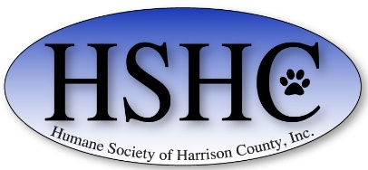

HUMANE SOCIETY OF HARRISON COUNTY DONATION FORM

You can help the unwanted, abandoned, and homeless pets of Harrison County by donating today.
Please make checks payable to: HSHC
and mail to: P.O. Box 4397 Clarksburg, WV 26302.
All donations are tax deductible. The animals thank you!

Name: ________________________________________________
Address: _______________________________________________
Email:: ________________________________________________

General Animal/Shelter Donation: | $________
Pet Sponsorship: | $________
Memorial or Honorarium Donation Amount: | $________

In Memory of:________________________________________
In Honor of: ________________________________________
Send Acknowledgement to: ___________________________________________
_________________________________________________________________

